Fareast International University  
 **

**Assignment 01:** Interpretation of some definitions.Submitted By: Submitted To:  
Name: Golam Morshed Anik Name: Ahmed Shafkat   
ID: 18120013 Designation: Lecturer  
Course: Artificial Intelligence   
Course Code: CSE-3115

1. **Simple Reflex Agents-**

In artificial intelligence, a simple reflex agent is a type of intelligent agent that performs actions based solely on the current situation, with an intelligent agent generally being one that perceives its environment and then acts. The agent cannot learn or take past percepts into account to modify its behavior.

**rules of simple reflex agent :**

Simple reflex agents act only on the basis of the current percept, ignoring the rest of the percept history. The agent function is based on the condition-action rule: "if condition, then action". This agent function only succeeds when the environment is fully observable.

**Figure:**

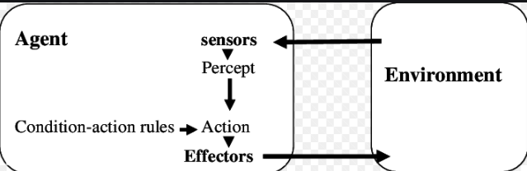

**For Example:**

For example if a mars lander found a rock in a specific place it needed to collect then it would collect it, if it was a simple reflex agent then if it found the same rock in a different place it would still pick it up as it doesn't take into account that it already picked it up.

**02.Model-Based Reflex Agents-**

Model-based reflex agents are made to deal with partial accessibility; they do this by keeping track of the part of the world it can see now. It does this by keeping an internal state that depends on what it has seen before so it holds information on the unobserved aspects of the current state.

**Figure:**

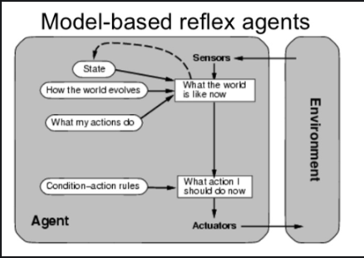

**For Example:**

Some examples of items with model-based agents aboard include the Roomba vacuum cleaner and the autonomous car known as Waymo. Both interact with their environments by using what they know--an internal model of the world--and their on-board sensors as well, to make moment-to-moment decisions about their actions.

**03.Goal-Based Agents-**

A goal-based agent takes it a step further by using a goal in the future to help make decisions about how best to reach that outcome. It uses a specific method known as search and planning, meaning it targets the goal ahead and finds the right action in order to reach it.

**Figure:**



**For Example:**

Google's Waymo driverless cars are good examples of a goal-based agent when they are programmed with an end destination, or goal, in mind. The car will then ''think'' and make the right decisions in order to deliver the passenger where they intended to go.

**04.Utility-Based Agents-**

A utility-based agent is an agent that acts based not only on what the goal is, but the best way to reach that goal.Think about it this way: A goal-based agent (yes, another of the intelligent agents out there) makes decisions based simply on achieving a set goal.

**Figure:**

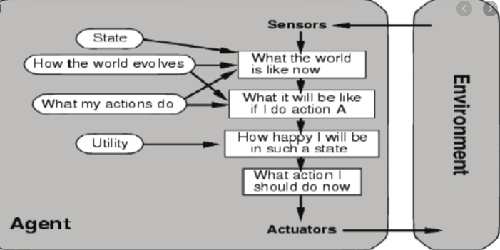

**For Example:**

A reflex agent, for example, could be a home thermostat that knows to start heating or cooling your house based on reaching a certain temperature. A utility-based agent is an agent that acts based not only on what the goal is, but the best way to reach that goal.

**05. Learning Agent-**

A learning agent is a tool in AI that is capable of learning from its experiences. It starts with some basic knowledge and is then able to act and adapt autonomously, through learning, to improve its own performance.

**Figure:**

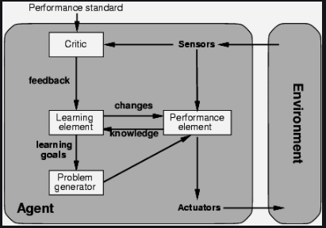

**For Example:**

The human is an example of a learning agent. For example, a human can learn to ride a bicycle, even though, at birth, no human possesses this skill.